**Experiment-1(a)**

**Aim:** Plot the IV characteristics of an N-MOSFET

**Apparatus used:** LTSpice XVII software

**Theory:**

N-type metal-oxide-semiconductor uses n-type (-) MOSFETs (metal-oxidesemiconductor field-effect transistors) to implement logic gates and other digital circuits. These nMOS transistors operate by creating an inversion layer in a ptype transistor body. This inversion layer, called the n-channel, can conduct electrons between n-type "source" and "drain" terminals. The n-channel is created by applying voltage to the third terminal, called the gate. Like other MOSFETs, nMOS transistors have four modes of operation: cut-off (or subthreshold), triode, saturation (sometimes called active), and velocity saturation

**Circuit Schematic:**

**NMOS input Schematic**

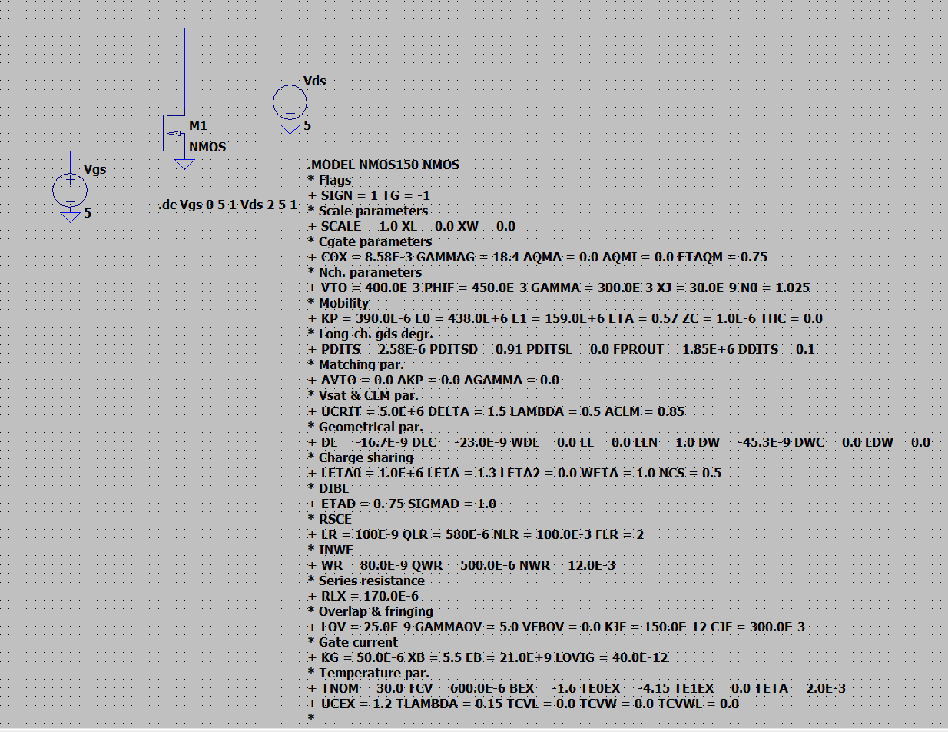

**Input Waveform:**

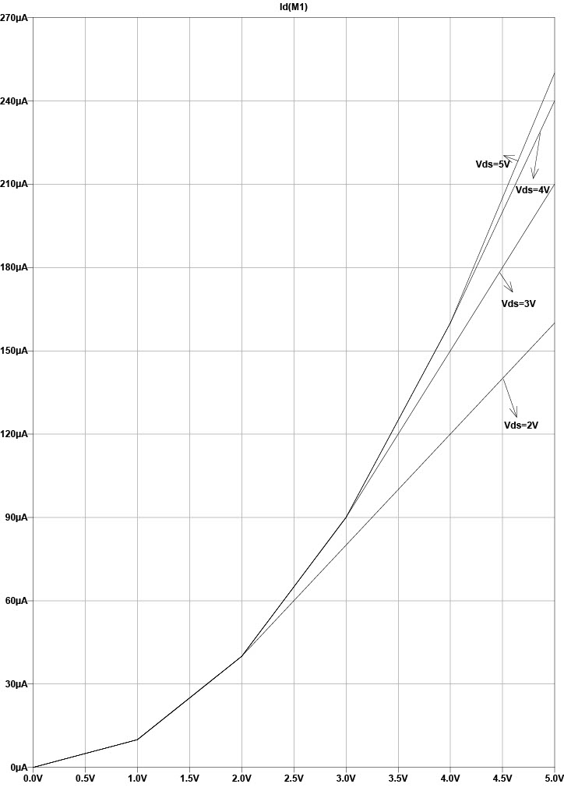

**Output Schematic:**

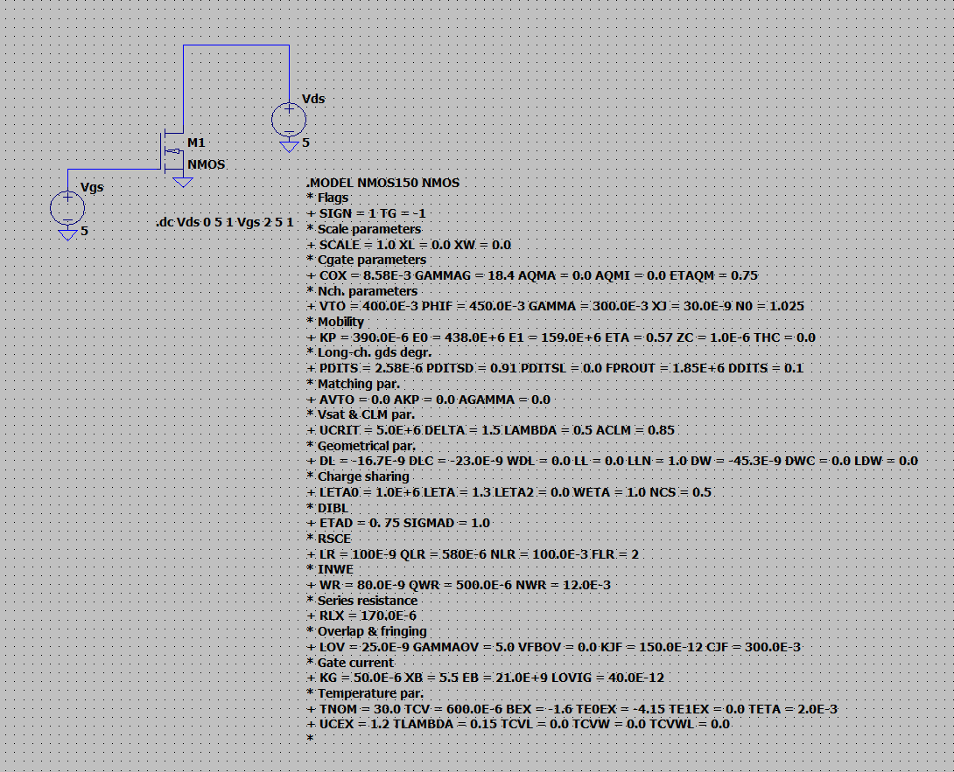

**Output Waveform:**

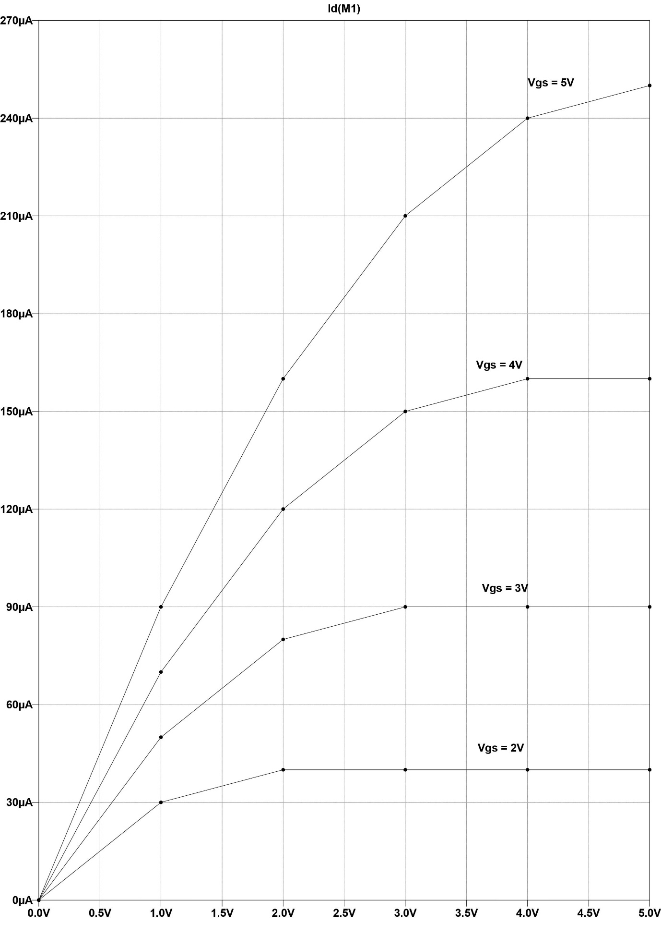

**Experiment-1(b)**

**Aim:** Plot the IV characteristics of a P-MOSFET

**Apparatus used:** LTSpice XVII software

**Theory:**

PMOS uses p-channel (+) metal-oxide-semiconductor field effect transistors (MOSFETs) to implement logic gates and other digital circuits. PMOS transistors operate by creating an inversion layer in an n-type transistor body. This inversion layer, called the p-channel, can conduct holes between p-type "source" and "drain" terminals. The p-channel is created by applying a negative voltage (-25V was common) to the third terminal, called the gate. Like other MOSFETs, PMOS transistors have four modes of operation: cut-off (or sub-threshold), triode, saturation (sometimes called active), and velocity saturation.

**Circuit Schematic:**

**PMOS input Schematic**

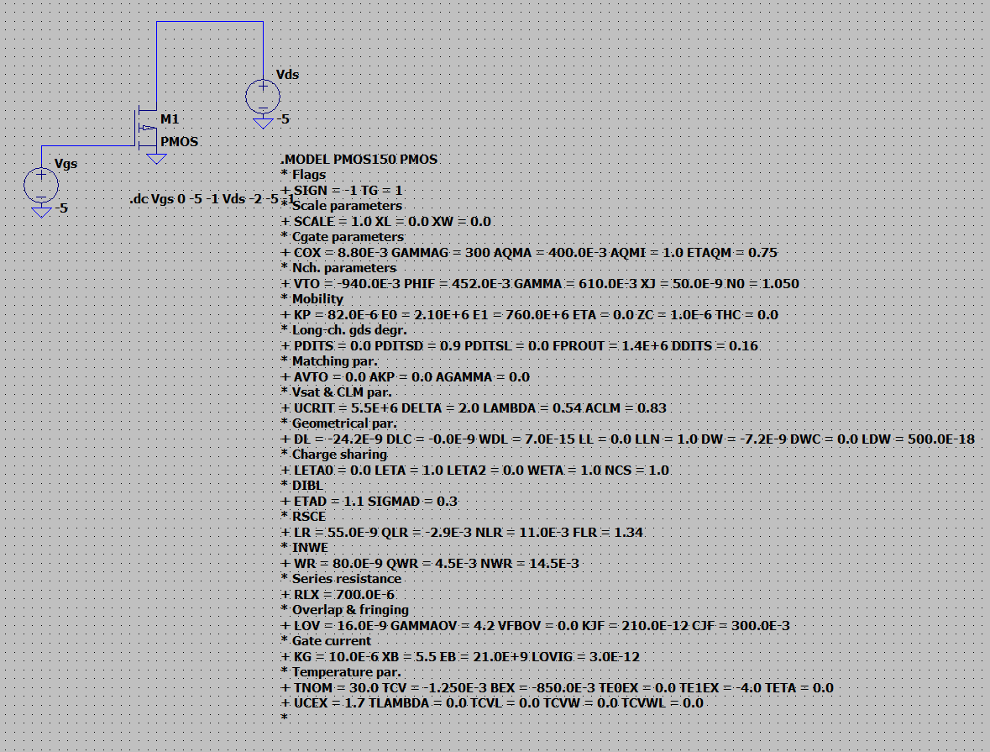

**Input Waveform:**

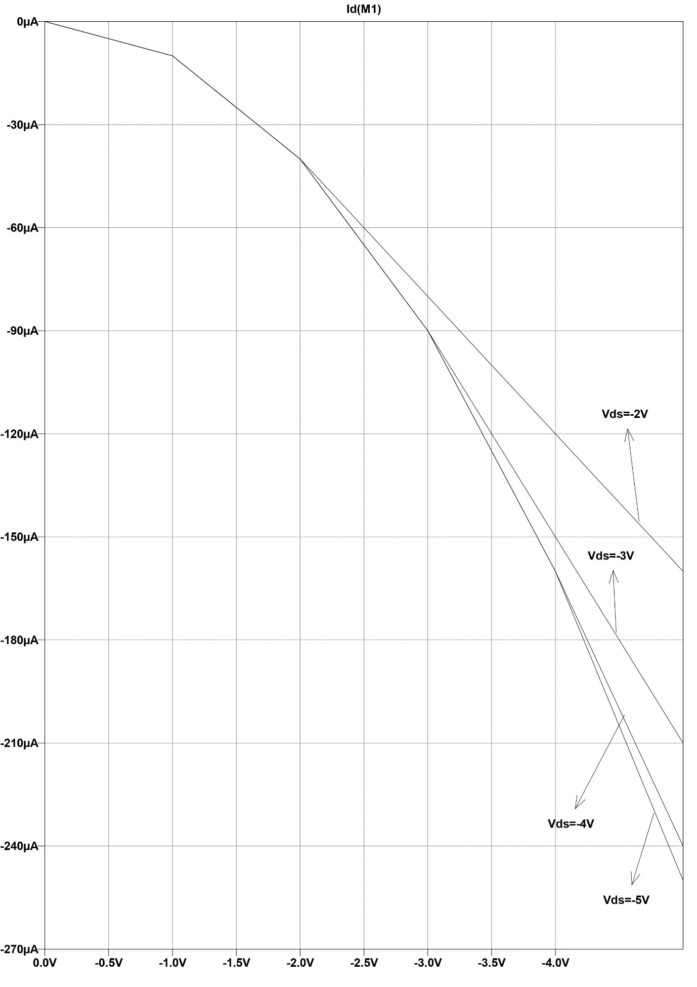

**Output Schematic:**

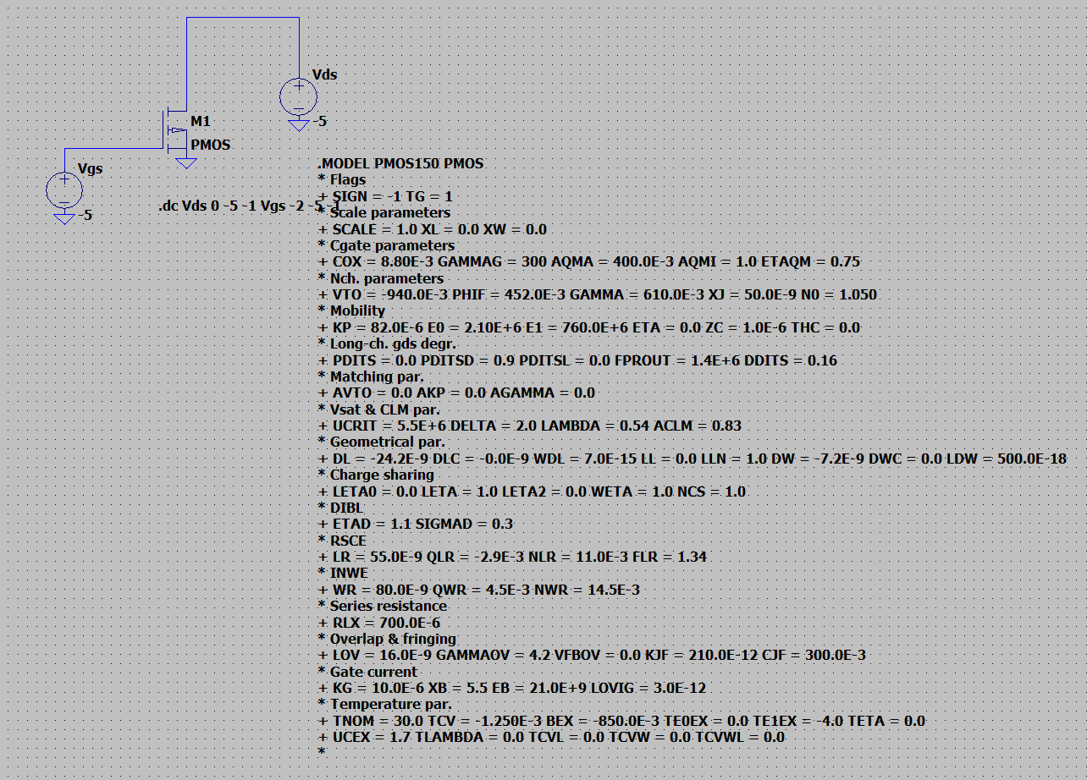

**Output Waveform:**

